How to Configure Dual Monitors for Remote Desktop

- Click the Start button and type Remote Desktop into the search box
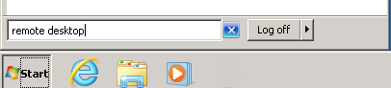
- Find Remote Desktop Connection in the search list and click it.
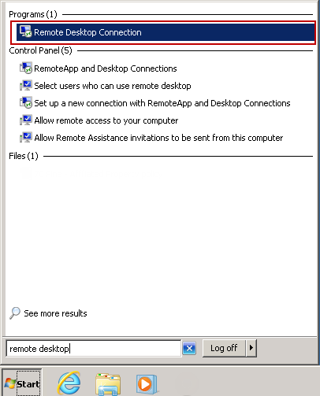
- In Remote Desktop, enter the computer name you were given, and then click the Show Options button.
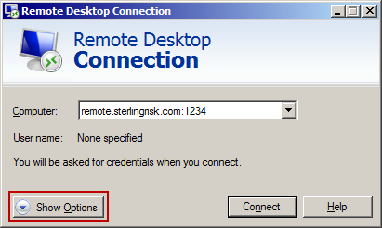
- Enter your username as sterling\flast (first initial last name).Then click Save As…
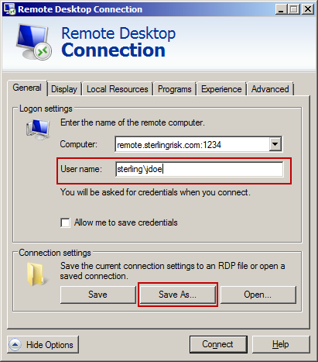
- In the Save As window, select Desktop. For file name user Sterling and then click save. Then close the Remote Desktop Connection window.
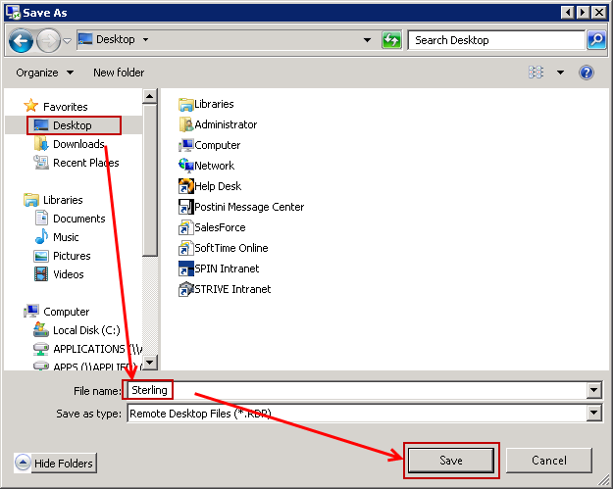
- Click the Start button and type Notepad into the search box. Find notepad in the search list and click it.
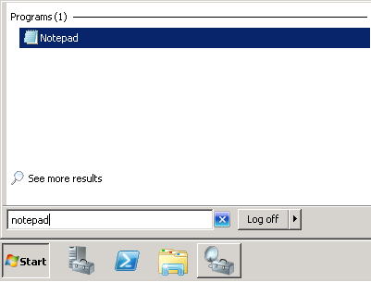
- In the Notepad file menu, select Open. Select Desktop. In the file name box type Sterling.rdp and then click Open.
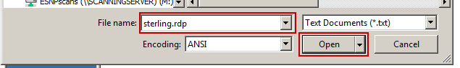
- At the end of the text, add a new line and type the following: span monitors:i:1
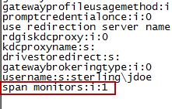
- Save the file and close Notepad.
- Double click the Sterling or Sterling.RDP icon on your desktop. Then follow the prompts as your normally would. In the future, to start a new dual monitor remote session, simply double click the Sterling icon on the desktop.
