How to change the default printer on a Terminal Server.
- Click the Start button and type notepad in the search box. Click the shortcut for Notepad.
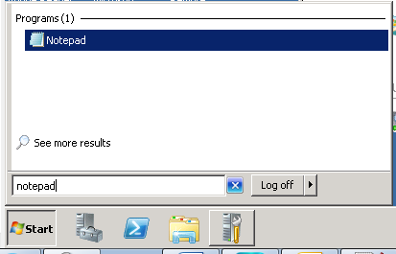
- In Notepad menu, Select File and then Print.
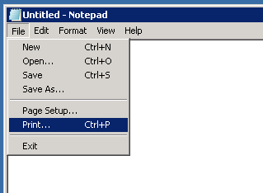
- Find the printer you would like to be default. Right click on it and select Set as Default Printer. Then hit Cancel to cancel the print job (the new default printer setting will remain). Then close Notepad.
