Open PDF Tools
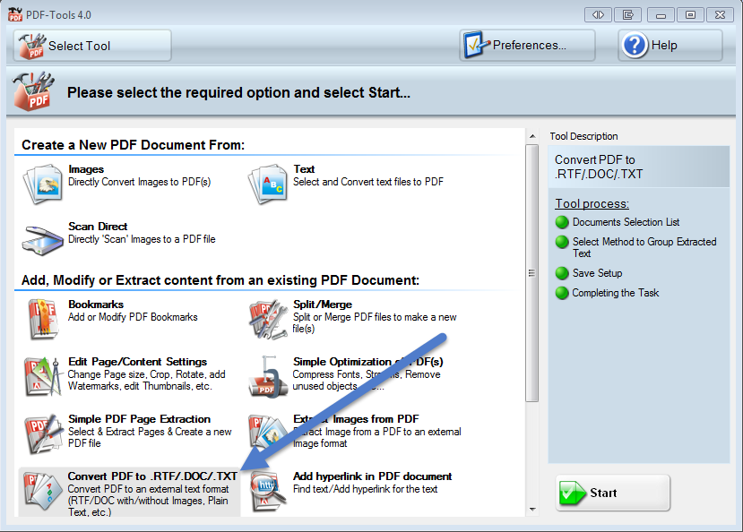
Double click CONVERT PDF to .RFT/.DOC/.TXT

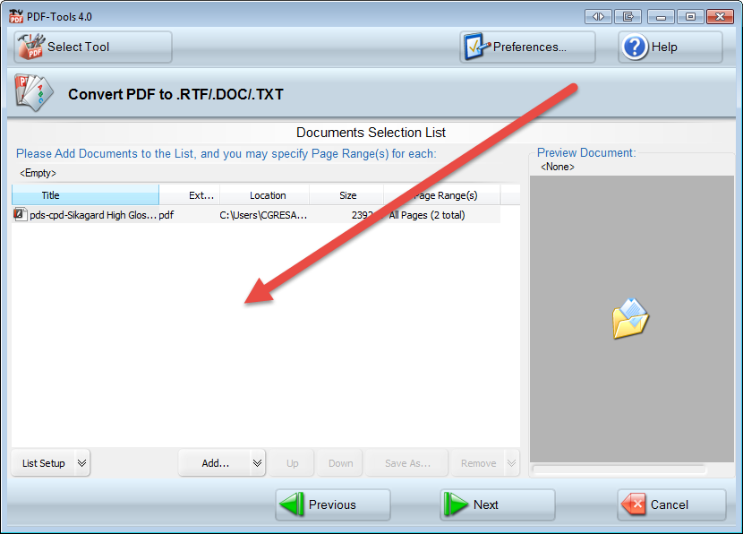
Drag and drop PDF to convert and click NEXT

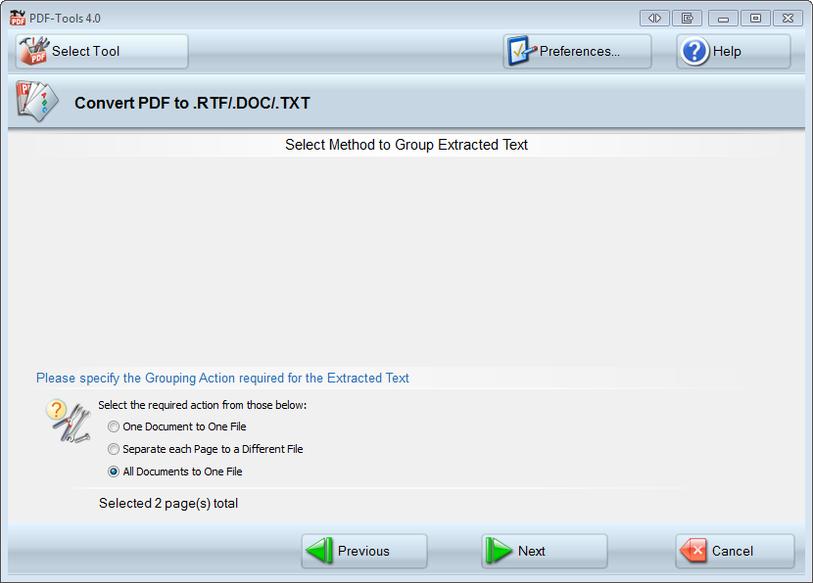
Select your output type (1 Doc to 1 File), (Separate each page to Different Files) or (all Docs to 1 file when adding multiple docs) and click NEXT

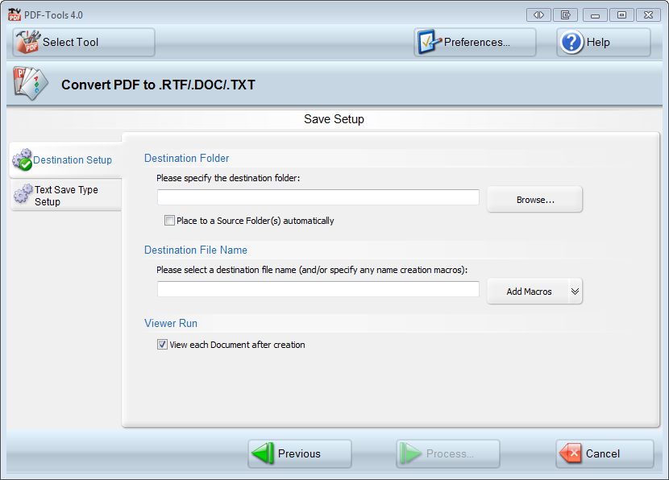
Set location and File name and Click PROCESS, FINISH

