How to enable Email Notifications on Box.com
- Go to https://app.box.com/settings/notification
- Under the “in folders I’ve joined” column check off the notifications would like to receive.
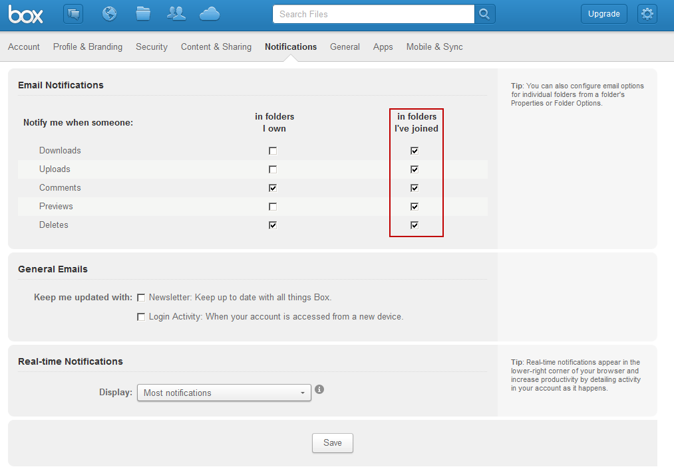
- Click Save

