How to merge multiple PDFs

- Open up PDF-Xchange 2012 Tools 4.0
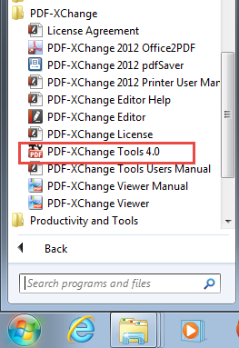

- Select Split/Merge and then click Start.
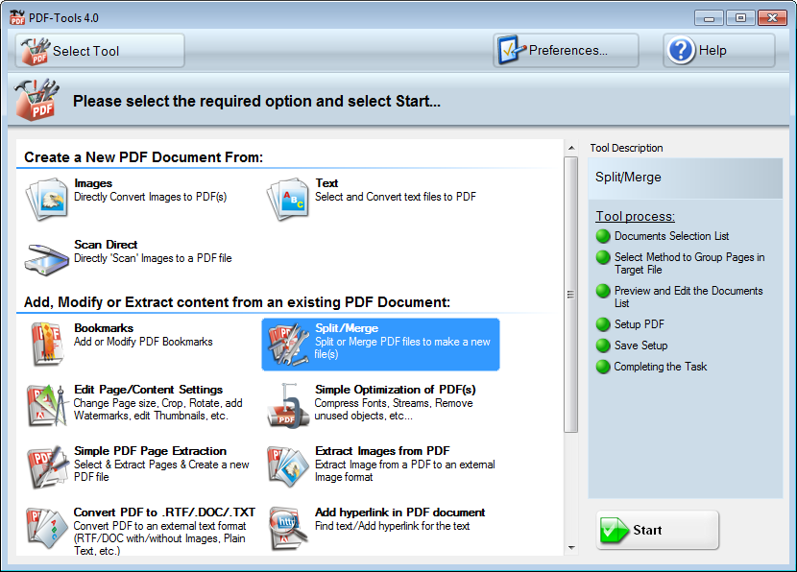

- Drag over the PDFs that you want combined. You can use the Up and Down buttons to indicate the order you would like them in. Then click Next.
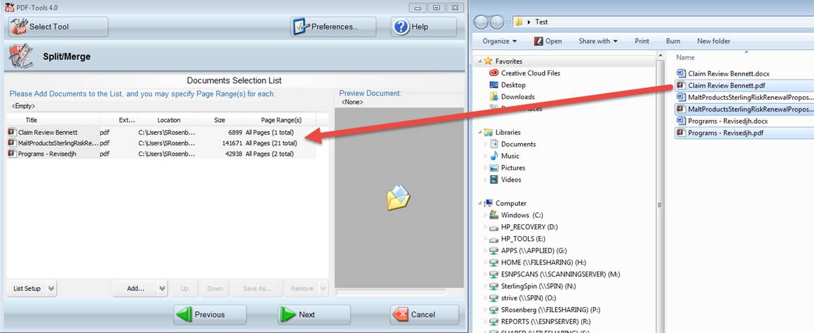

- Use the default settings then click Next. Then click next on the two screens that follow.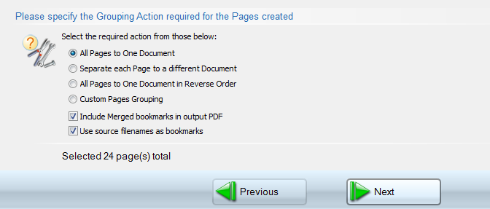

- On the final screen you must give a location the save the PDF, and a name for it. Then click Process.
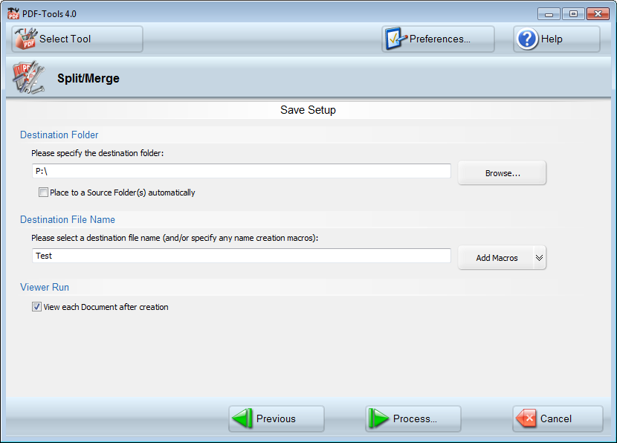

- Your newly created PDF should now open.

