How to restart a computer remotely

Click “Start” and then click “Windows Security”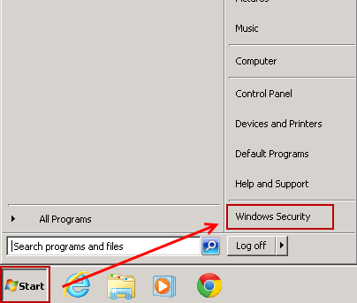
Click the little triangle in the right hand corner of the screen, and then click “Restart”
