How to share calendars in Outlook 2010
Follow this steps to give others permission to see your calendar, request permission to view theirs, and to open shared calendars.
- Click “Calendar” on the bottom left corner of Outlook.
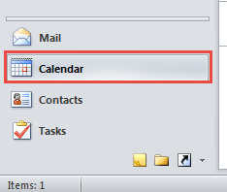
- Click “Folder” and then “Share Calendar” on the top ribbon bar.
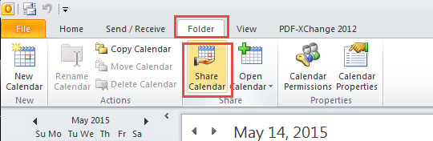
- A new message will open. In the “To…” field enter the people whom you would share calendars with. Be sure to check the box for “Request permission to view recipient’s Calendar”. Then click “Send”.
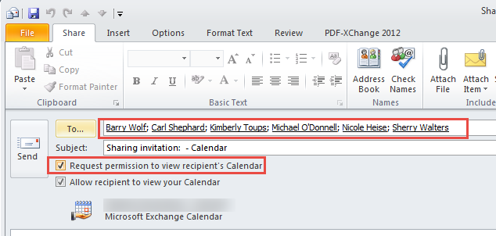
- A new window will appear. Click OK
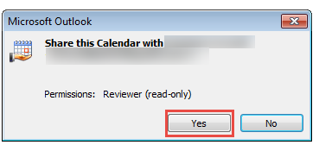
- The recipient(s) will receive your request. When they approve it you will receive an email notifying you. From this email you can add their calendar to your Outlook by clicking “Open this Calendar”
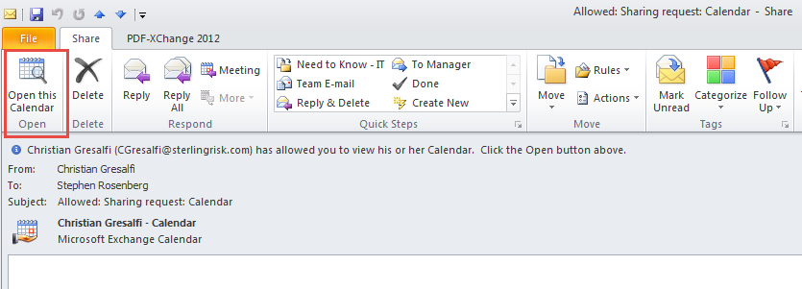
If you receive and invite to share your calendar, do the following to share with them.
- Open the email requesting access to your calendar.
- Click the “Allow” button.
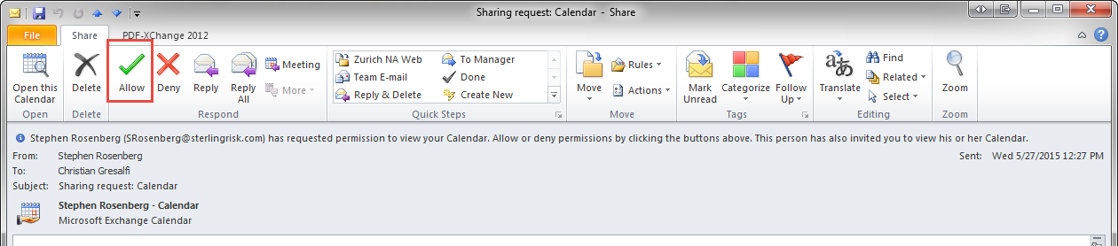
- A new window will appear. Click “Send”
- A new window will appear. Click OK
- A message will appear telling you that you have successfully shared your calendar.
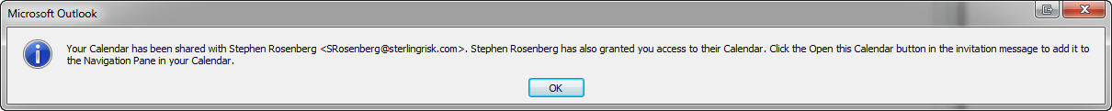
- Go back to the original email requesting access to your calendar. From this email you can add their calendar to your Outlook by clicking “Open this Calendar”.
