How to start a LogMeIn Rescue remote support session.

- Open Safari. In the address bar, type LogMeIn123.com and then hit the return key. Do not click any of the suggested links.
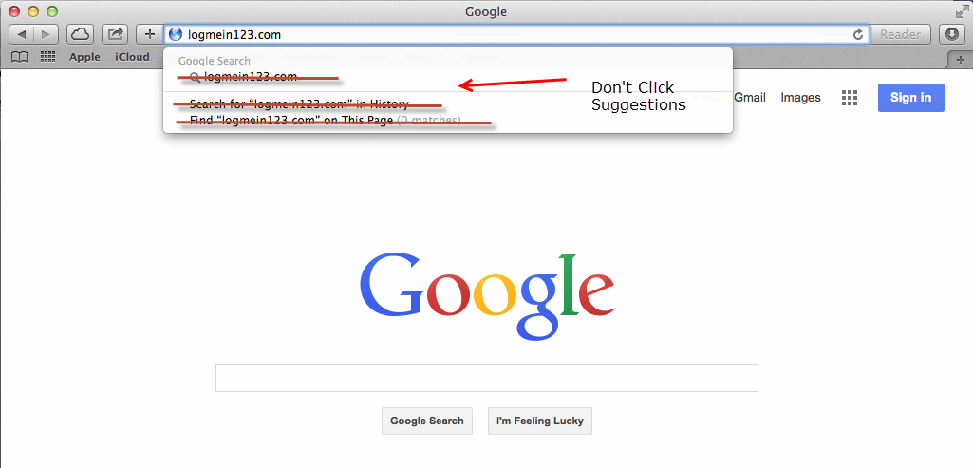
- This should bring you to the LogMeIn Rescue page. Enter the 6-digit code provided by the tech.
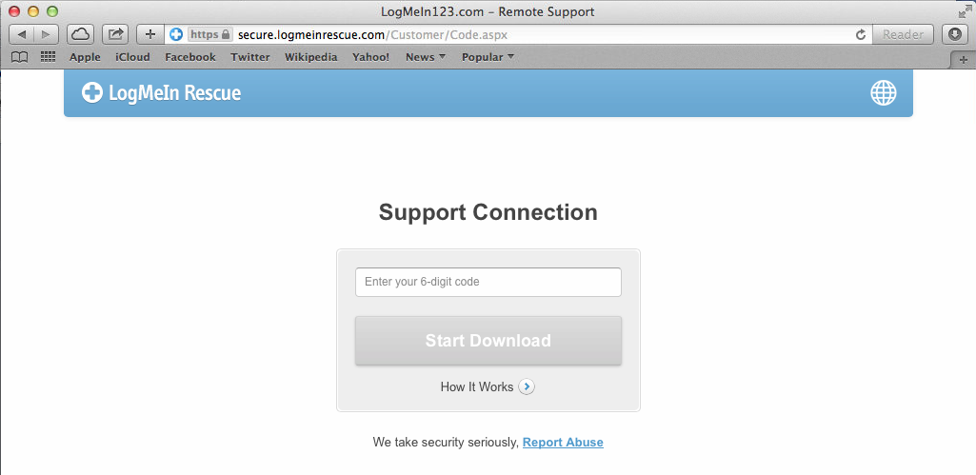
- You will be brought to a download page. Wait a few seconds and the download will happen automatically.
- Click the “Arrow in a circle” in the top right corner of Safari. Then double click Support-LogMeInRescue in the list of downloads.
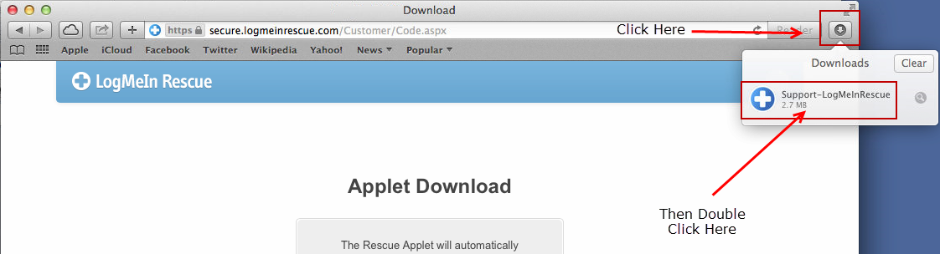
- You will receive a window asking if you are sure about open this file. Click open.
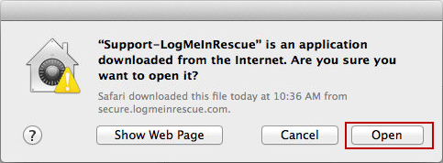
- A new window will open advising you that you are being connected to a tech.
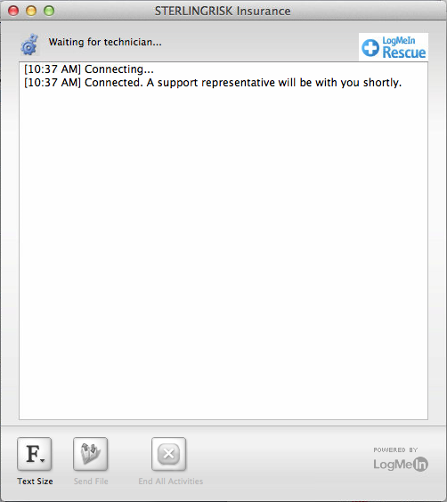
- You will be asked if the tech should be allowed access to your computer. Click OK.
