How to remote into your work PC from Mac OS X

- First you must download and install Microsoft Remote Desktop from the Mac App Store (this requires an Apple ID).

- Click on “App Store” in the dock
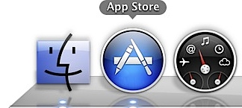

- In the top right corner search for “Microsoft Remote Desktop”
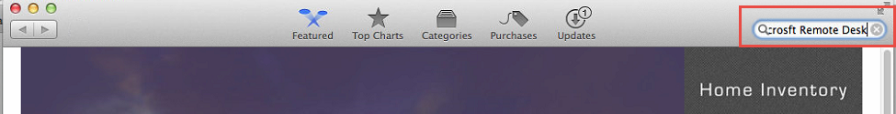
- Install the one that looks like this…
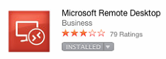

- Once installed, open the program and click on “New”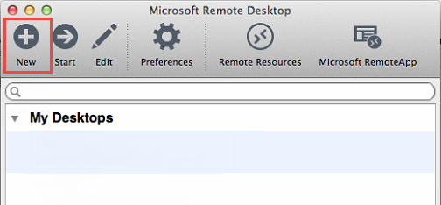

- Enter the details as shown below…
- Replace the xxxx for PC name with the port number located in your profile in HELPDESK.
- The username is sterling\(your first initial and last name).
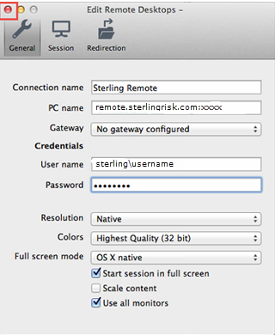

- Click the Red Dot at the top left corner of the window to save.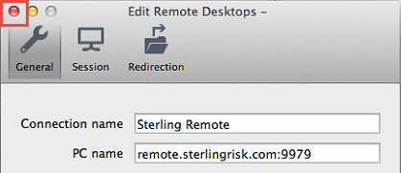

- Double click “Sterling Remote” to start the connection.
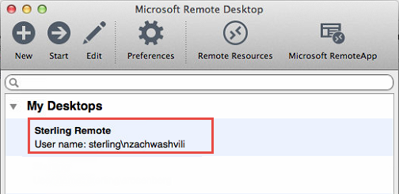

- If you receive the below message, click continue
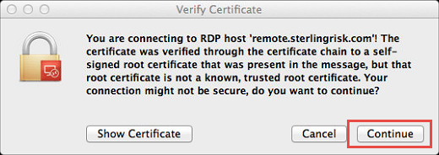

- You should now be connected to your office computer

