How to Configure Remote Desktop on iOS Devices
- On the App Store, download Microsoft Remote Desktop. It is a free app. The icon looks like this:
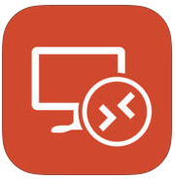
- Open Remote Desktop (it may say RD Client). Tap the plus button on the top right corner. Then tap Add PC or Server.
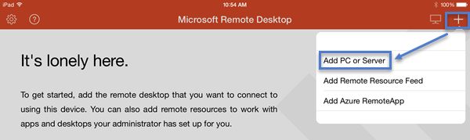
- A new window will open.
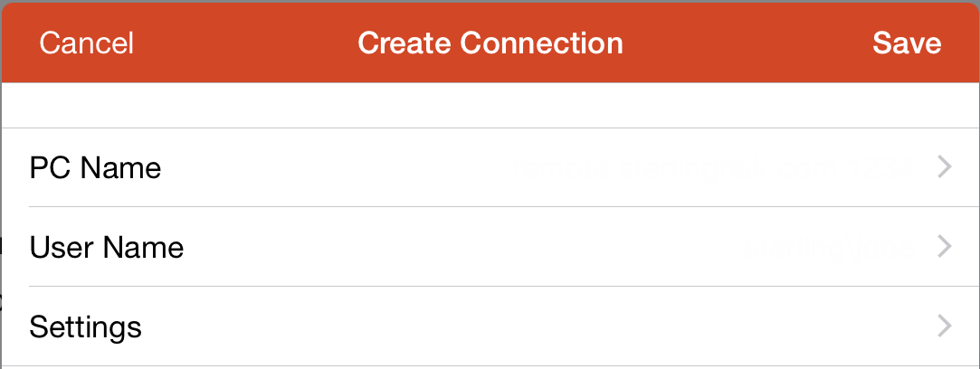
- Tap PC Name. A new window will open. Enter Remote.sterlingrisk.com: followed by your 4 digit port number. Then tap Done.
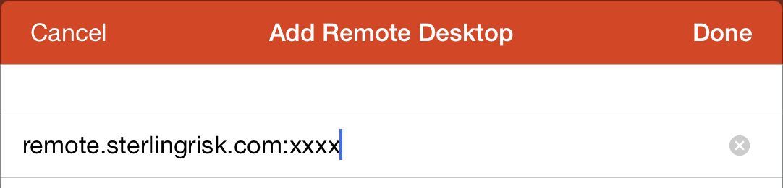
- Tap User Name. A new window will open. Enter sterling\ followed by your username. Then tap Done. Do not enter your password. Do not select Store username and password.
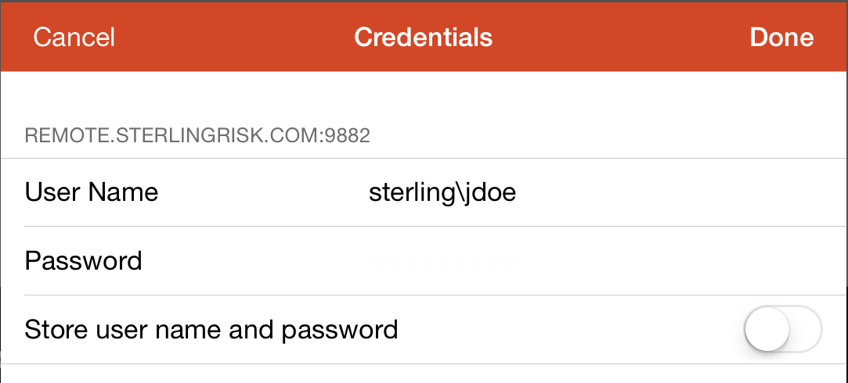
- On the Create Connection window tap Save.
- Tap the remote.sterlingrisk.com icon to remote in. Going forward this is all you will need to do to connect. You will not need to configure all of the settings again.
