Remote Desktop Connection Instructions

Before starting you will need the following information as found in your Help Desk user profile:
Computer: remote.sterlingrisk.com:XXXX (XXXX = your RDP port number)
User: Sterling\Your network user name (network name usually FirstInitialLastName, ie: JDoe).
Password: Your network password (same password you use to login at work)

Notes:
- In order for remote access to work, your work computer must be on, and your remote PC must have a valid connection to the Internet. YOU are responsible for downloading/installing/configuring the Remote Desktop software on your remote PC and ensuring that you have a proper Internet connection.
- Remote access is unavailable from 12:00 AM – 6:00 AM.
- For PCs with firewalls: Port 3389 must be open, as well as the port number after the “:” in your connection IP address (ie: 99xx).
- Windows users must have Windows 7 or Higher. XP and Vista are not supported.
- Mac users must have OS X 10.6.6 or Higher. Older version are not supported.

Windows 7 and Windows 10

- In Windows 7, Click the Start button and type Remote Desktop into the search box
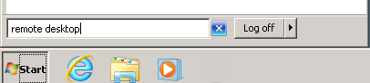
In Windows 10, type Remote Desktop into the search box next to the start button.
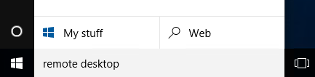
- Find Remote Desktop Connection in the search list and click it.
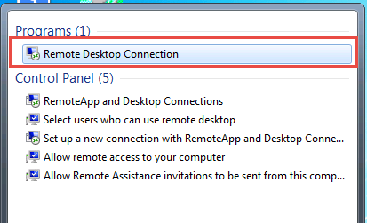
- In Remote Desktop, enter the address you were given. Click Connect.
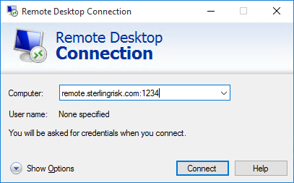
- If you get the below box, click “Use another account”.
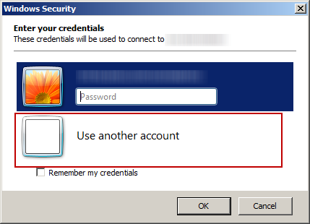
- Then enter your domain\username (sterling\jdoe) and your network password. Then click OK.
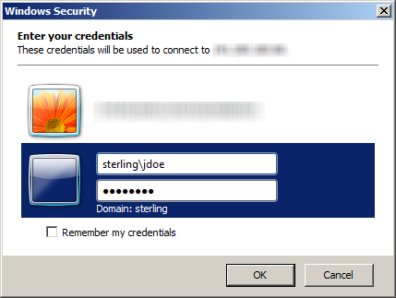 or 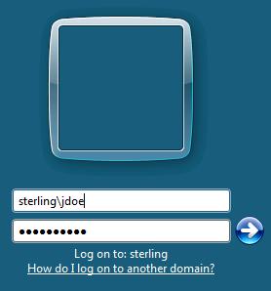
- You may get the below warning. Click “Yes” to continue.
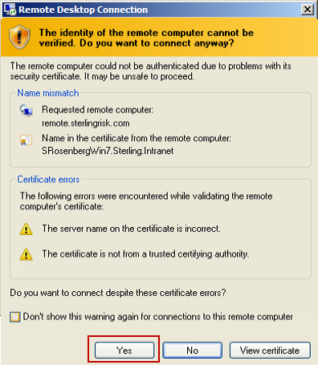
- You should now be connected to your office computer

Windows 8

- Click the window key on your keyboard
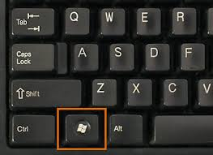
- You will now have a search box in the upper right corner of your screen
In the search box type Remote Desktop. Then click “Remote Desktop Connection”.
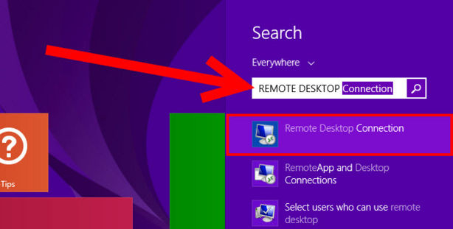
- In Remote Desktop, enter the address you were given.

- If you get the below box, click “Use another account”.
- Then enter your domain\username (sterling\jdoe) and your network password. Then click OK.
or
- You may get the below warning. Click “Yes” to continue.
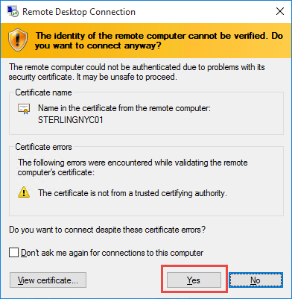
- You should now be connected to your office computer

Mac OS X

- First you must download and install Microsoft Remote Desktop from the Mac App Store (this requires an Apple ID).

- Click on “App Store” in the dock
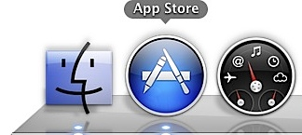

- In the top right corner search for “Microsoft Remote Desktop”
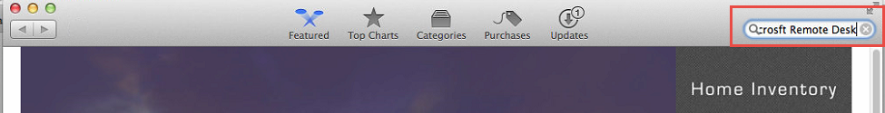
- Install the one that looks like this…
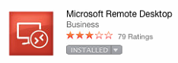

- Once installed, open the program and click on “New”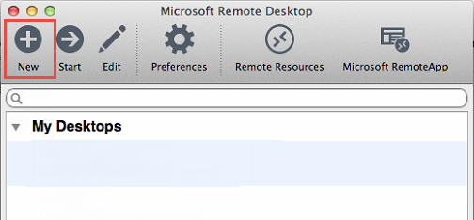

- Enter the details as shown below…
- Replace the xxxx for PC name with the port number located in your profile in HELPDESK.
- The username is sterling\(your first initial and last name).
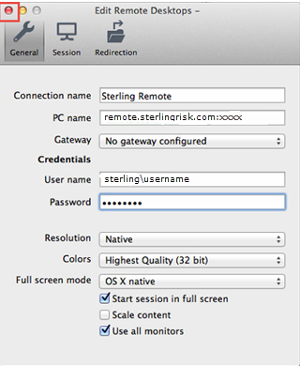

- Click the Red Dot at the top left corner of the window to save.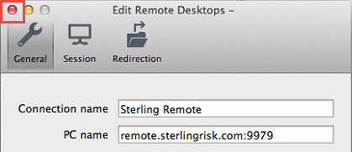

- Double click “Sterling Remote” to start the connection.
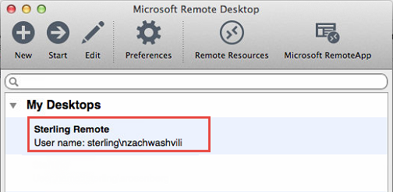

- If you receive the below message, click continue
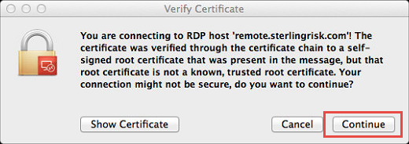

- You should now be connected to your office computer

For Tablets (like the iPad):
- On the App Store or Google Play Store, download Microsoft Remote Desktop. It is a free app. The icon looks like this:
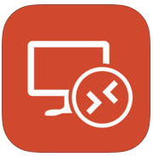
- Open Remote Desktop (it may say RD Client). Tap the plus button on the top right corner. Then tap Add PC or Server.
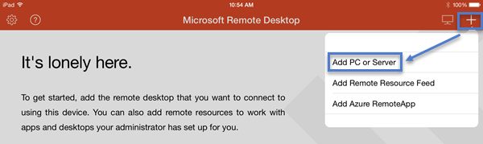
- A new window will open.
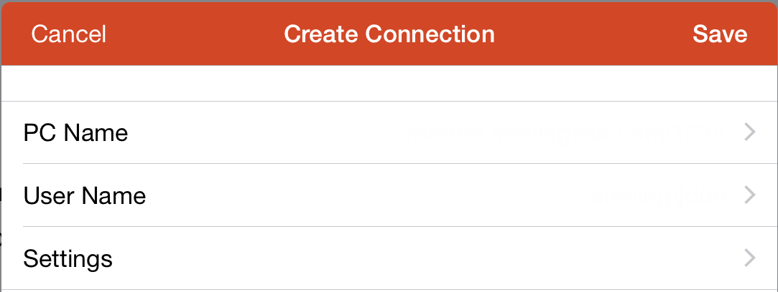
- Tap PC Name. A new window will open. Enter Remote.sterlingrisk.com: followed by your 4 digit port number. Then tap Done.
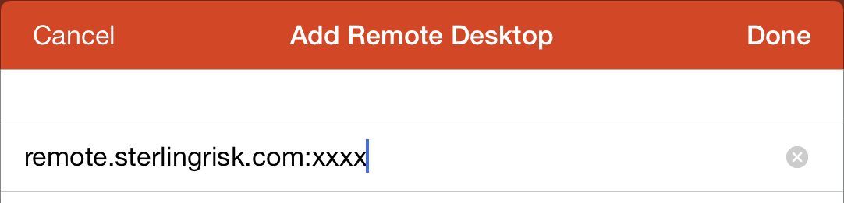
- Tap User Name. A new window will open. Enter sterling\ followed by your username. Then tap Done. Do not enter your password. Do not select Store username and password.
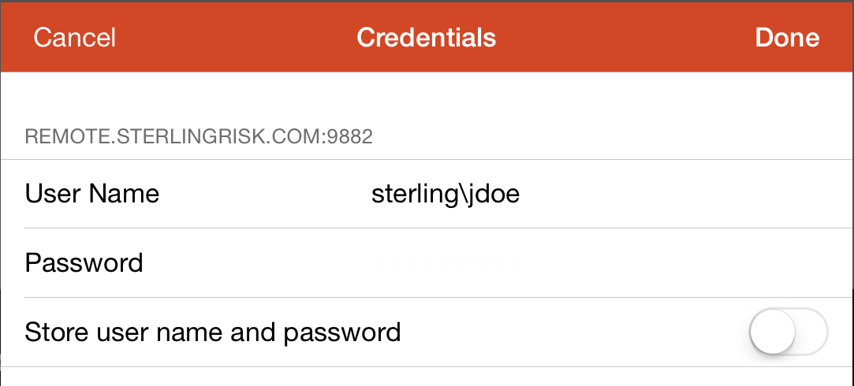
- On the Create Connection window tap Save.
- Tap the remote.sterlingrisk.com icon to remote in. Going forward this is all you will need to do to connect. You will not need to configure all of the settings again.
