Add or Change Zoom Virtual Background on Desktop
- Sign into the Zoom desktop client on your PC. (Remember to sign in using SSO).
- Click your profile picture or initials in the top right corner, then click Settings.
- Select Backgrounds & Filters on the left side.
- Click on an image or video to select the desired virtual background. You will find custom backgrounds for SterlingRisk, Sterling Analytics, SterlingRisk Aviation and SterlingRisk Employee Benefits.
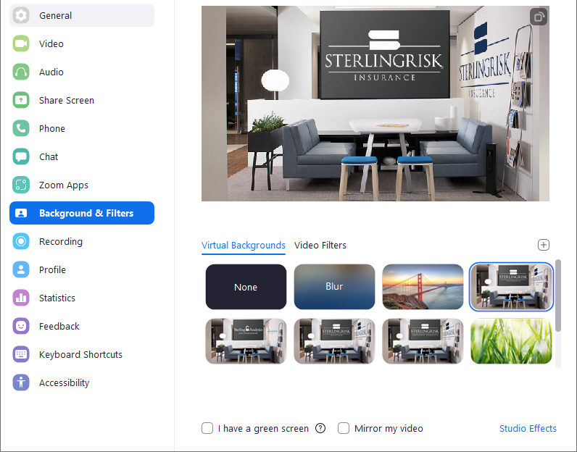
- You can also add your own image by clicking and choosing if you want to upload an image or a video.
- Check I have a green screen if you have a physical green screen set up. You can then click on your video to select the correct color for the green screen.
Notes:
  - To disable Virtual Background, open the virtual background options again and choose the option None.
  - Ensure that you are using a solid background color when I have a green screen is checked.
  - After you select an option, that virtual background will be used for your future meetings.

