Add or Change Zoom Virtual Background on Mobile App
Mobile Device requirements
- Android
  - Google, OnePlus, Samsung device required
  - Android 8.0 or higher required
  - arm64 processor with 8 cores or higher, and 3GB or higher RAM required
- iPhone
  - iPhone 8 or newer is required.

- Sign into the Zoom mobile app. (Remember to sign in using SSO).
- While in a Zoom meeting, tap More in the controls.
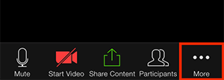
- Tap Virtual Background (Android) or Background and Filters (iOS).
- Tap the background you would like to apply or tap + to upload a new image. You will find custom backgrounds for SterlingRisk, Sterling Analytics, SterlingRisk Aviation and SterlingRisk Employee Benefits.
- Tap Close after selecting the background to return to the meeting.
Notes:
  - To disable Virtual Background, open the virtual background options again and choose the option None.
  - Ensure that you are using a solid background color when I have a green screen is checked.
  - After you select an option, that virtual background will be used for your future meetings.

