How to Host and Join Meetings with Zoom Rooms

Scenario 1 – You are scheduling/joining a meeting that you ARE the HOST of:

- Open the Outlook Calendar and create a new Zoom meeting invitation
  - Set the title, date, and time of your meeting
  - Click the “Add a Zoom Meeting” button in the Outlook ribbon. A Zoom meeting will be generated
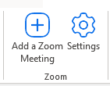
  - Click any blank area in the Location field. A drop down will appear with available conference rooms. Click the room you would like to use
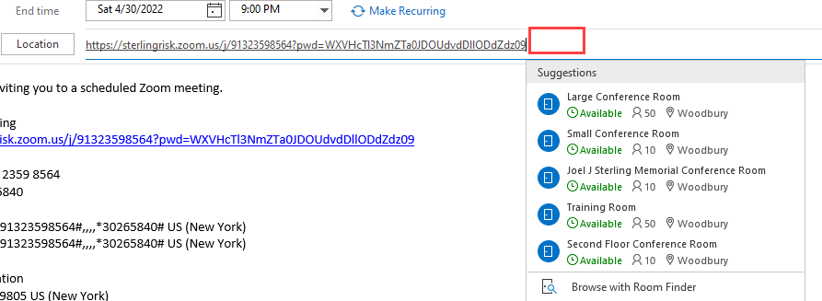

  - Add invitees to the required field
  - Click send to send the invitation and reserve the Zoom Room
- Go into the Conference Room from which you wish to host the meeting
  - Be sure the Polycom TC8 Polycom Tablet is in “Zoom Rooms” Mode using touch screen (not BYOD mode)
  - Start/Join the meeting from the Polycom TC8 Tablet Meetings list

- Use the Polycom TC8 Tablet located on the table to control the meeting from there (refer to the “Zoom Room Meeting Controls” supplemental attachment for additional info).

Scenario 2 – You are joining a meeting that you are NOT the host of – No Mobile Device Method

Option 1 – Invite the Conference Room to the meeting, then Join meeting from Polycom TC8 Tablet.

- From your Outlook calendar, Forward the Zoom Meeting invite to the Conference Room that you wish to be in for the meeting, and await the email confirmation that the room has accepted
- Proceed into the conference room that you sent the invitation to
- Be sure the Polycom TC8 tablet is in “Zoom Rooms” Mode using touch screen (not BYOD mode)
- Highlight the meeting on the Polycom TC8 tablet Meetings list, and click Join.
- Use the Polycom TC8 Tablet located on the table to control the meeting from there (refer to the “Zoom Room Meeting Controls” supplemental attachment for additional info).

Option 2 – Join the meeting using Meeting ID and Passcode.

- Proceed into the conference room that you wish to join from
- Be sure the Polycom TC8 tablet is in “Zoom Rooms” Mode using touch screen (not BYOD mode)
- From the Polycom TC8 tablet, press “Join”
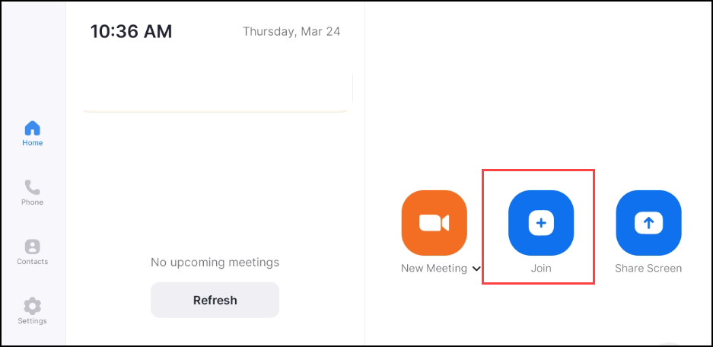

- Enter the meeting ID and tap “Join”
- If prompted, enter the passcode
- Use the Polycom TC8 Tablet located on the table to control the meeting from there (refer to the “Zoom Room Meeting Controls” supplemental attachment for additional info).

Scenario 3 – You have the Zoom App on your mobile device, and you are either hosting or joining a meeting

- FIRST TIME USE ONLY. Once this is done one time, you can start with Step 2
  - Go to https://sterlingrisk.zoom.us/profile
  - Scroll to the bottom of the page and find “Calendar and Contacts Integration”
  - Click “Configure Calendar and Contacts Service”
  - If you’re email address is already there, you don’t need to do anything further, please proceed to step 2
  - Select “Office 365” and then click “Next”
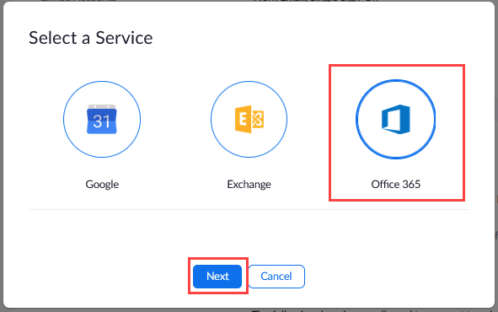

  - Make sure the “Read” boxes are checked, and then click “Authorize”
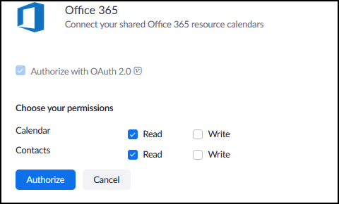

  - If prompted to sign in, enter your email address and network password

- Proceed into your desired conference room
- Open the Zoom App on your mobile device
- Click the “Meetings” icon
- Select the meeting you wish to join from your list
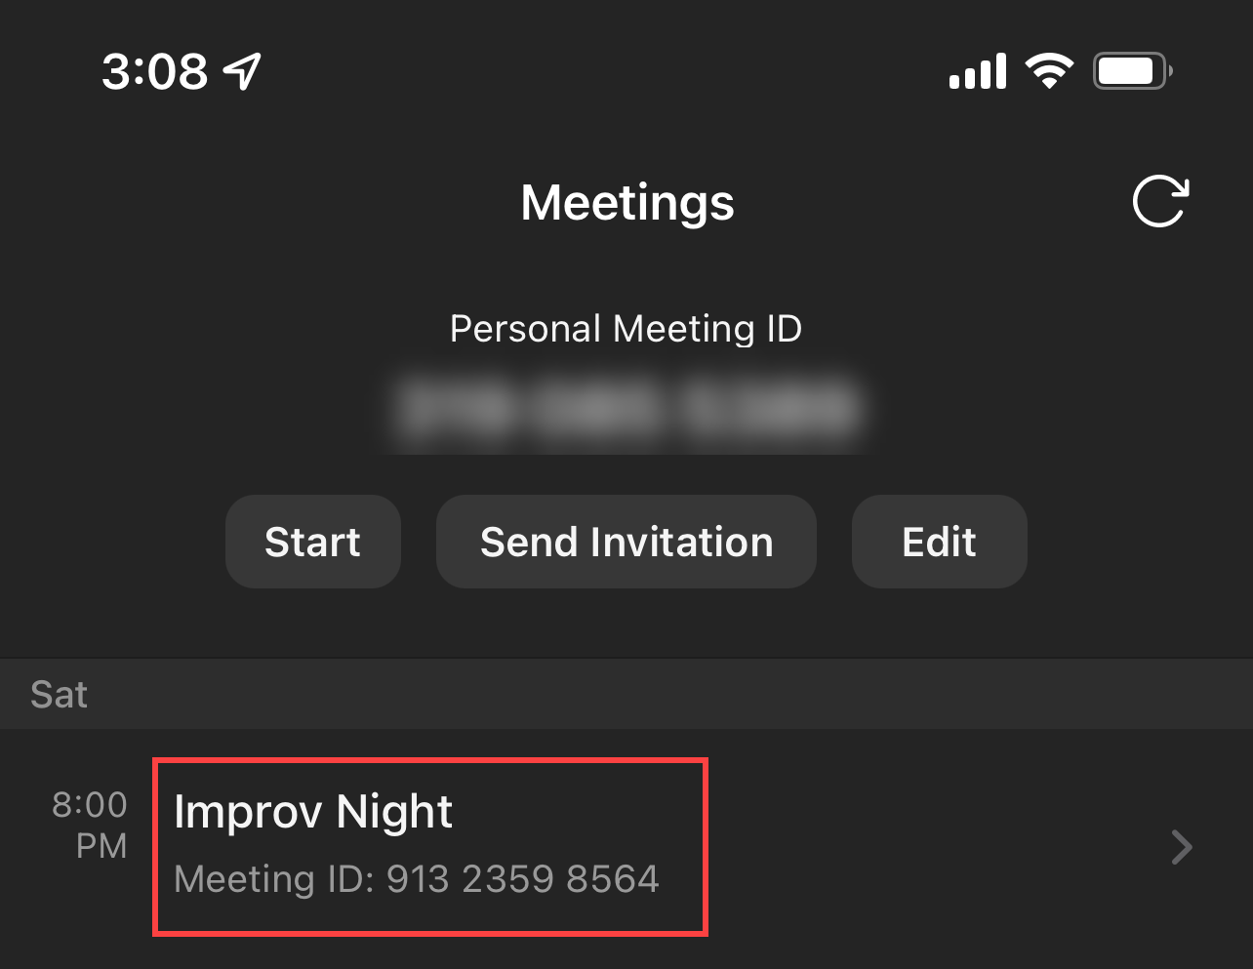

- Tap “Join from a Room”
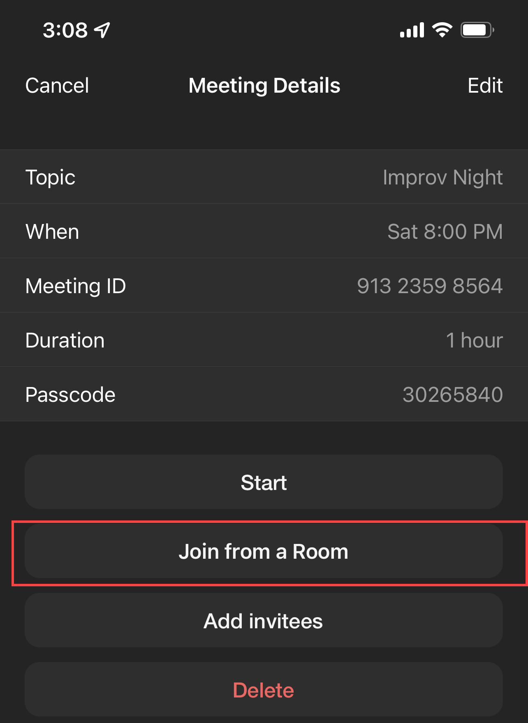

- The app should automatically connect to the Zoom Rooms setup in that room and start the meeting from the Polycom TC8 Tablet located on the table. If the meeting does not auto-start, you should be prompted to enter the Sharing Key displayed on the top right corner of the TV, and then just click on the “Pair” button to start the meeting.

- Use the Polycom TC8 Tablet located on the table to control the meeting from there (refer to the “Zoom Room Meeting Controls” supplemental attachment for additional info).

Scenario 4 – You are in the conference room and wish to start an impromptu meeting:

- Be sure the Polycom TC8 Polycom Tablet is in “Zoom Rooms” Mode using touch screen (not BYOD mode).
- Click on the “New Meeting” icon.
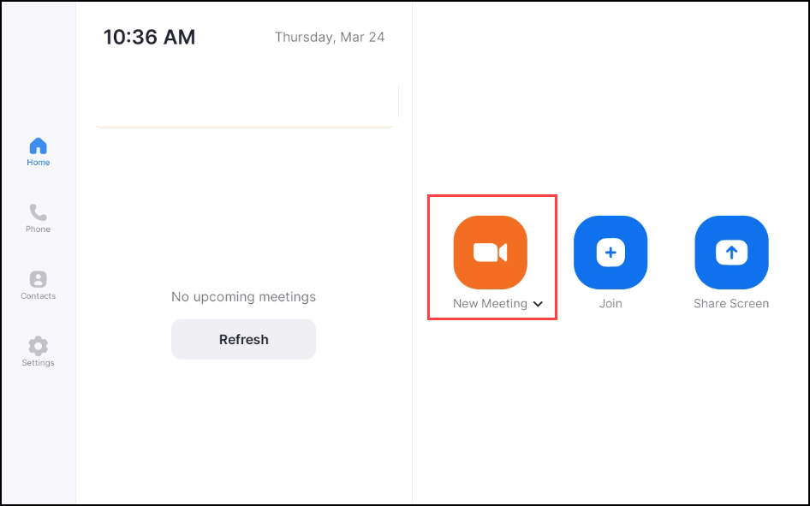
- Tap the ⓘ next to the meeting name at the top of the screen to get the meeting ID and passcode.
- To invite users, tap “Meeting Participants” and then tap “Invite” on the lower left corner of the window.
- You can invite using the company directory or by sending an email
- Use the Polycom TC8 Tablet located on the table to control the meeting from there (refer to the “Zoom Room Meeting Controls” supplemental attachment for additional info).

Sharing Content While in a Zoom Rooms Meeting:

Please note that once you are connected to any Zoom Rooms meeting, you can tap the “Share” button to open up a window to the Conference Room PC and share that screen. From there, you can also remote into you own PC in order share presentations, spreadsheets, etc. If you are unfamiliar with how to remote into your PC from a Conference Room, please feel free to reach out to someone from the I.T. team for assistance.

