How to log into Zoom on an iPhone

- Open the Zoom app and tap “Sign In”.
- Tap “Sign in with SSO” at the bottom of the screen.
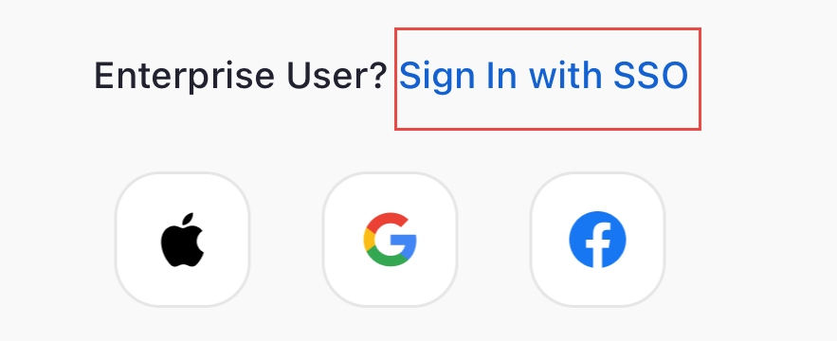
- Enter in our company domain as “sterlingrisk” (so that the whole entry says “sterlingrisk.zoom.us”).
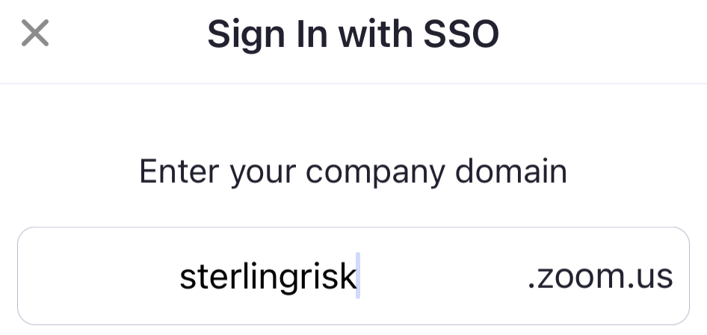
- You will then be brought to a Microsoft sign in web page in Safari. Log in with your SterlingRisk.com (or bolstonst.com, essentialsp.com or pdiins.com) email address and network password. If asked if you want to stay signed in, choose yes.
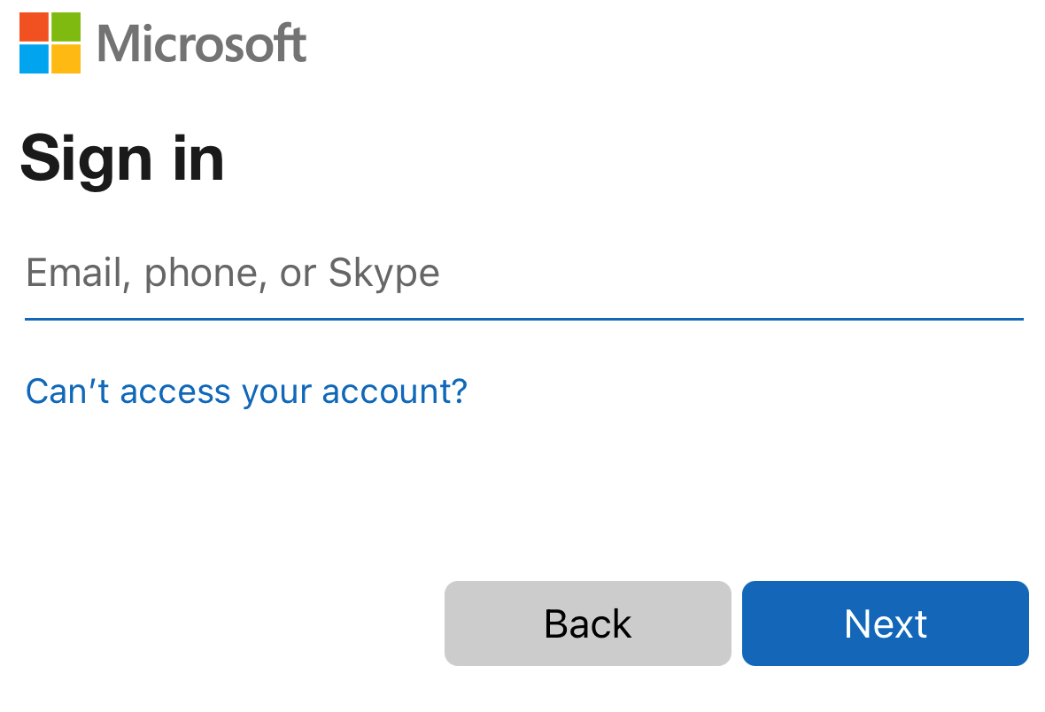
- Approve the Duo alert that you receive.
- Go back to Safari. Tap the "Launch Zoom" button. If prompted to “Open this page in ‘Zoom’?”, click Open.


